# RFID Reader User Guide

**Installation**

1. Open Visual Studio 2017, create an empty project and place all header and cpp files into project.
2. Left Click on project directory and go to properties.
3. Under C++, go to General and click on additional include directories.
4. Find the path of the **stapi** folder which includes Skyetek’s API files, copy and paste the path.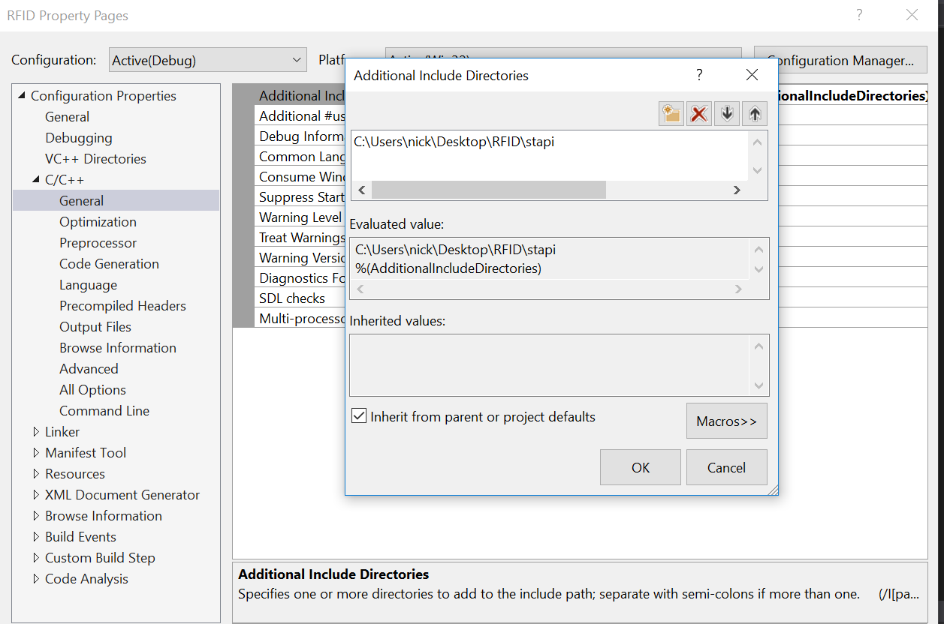
5. Open Linker, find additional include directories, repeat step 4.
6. Under Linker, go to input. Click on additional include directories, this time copy and paste the path of the stapi.lib.
7. Download stapi.dll file from website. Place this file into your system32 and syswow64 folder.
8. Finally click build solution and run the program.

**Program user guide**

1. Connect the RFID device to your computer.
2. Run the program.
3. Click on Connection > Start from the menu.
4. Several messages will display to show connection of the reader. Once the reader has been detected, it will ask the user to start reading.
5. Get a tag and put it close to the reader.
6. Notice the window will output the tag code.
7. If user wants to stop scanning, simply press disconnect. RFID reader will stop scanning at this point.
8. User can terminate the program by pressing EXIT from the menu.